Project Name:

**MErciado amusement park**

**(Feel the joy)**

Group Member:

Shabbir afzal khan

Teacher Name:

SIR S.M TAHA

DOCUMENTAON

**ACKNOWLEDGMENT**

I am really grateful because i managed to complete my

E-project within the time given by My teacher,

Sir S.M TAHA. This assignment cannot be completed without the effort and co-operation from my teacher, Group member; **SHABBIR AFZAL KHAN.**

We also sincerely thank our teacher **Sir S.M TAHA**

for the guidance and encouragement in finishing this project and also for teaching us in this course.

Last but not the least, I would like to express My gratitude to My friends and respondents for the support and willingness directly or indirectly to spend some times with me to fill in the questionnaires.

**CONTENT**

* Introduction------------------------------------------------ 5
* Objectives of the Project------------------------------ 7
* Topic of our Project-------------------------------------- 8
* Hardware/Software Requirements----------------- 9
* Work Analysis---------------------------------------------- 10
* Design ------------------------------------------------------- 11
* Homepage ------------------------------------------------ 12
* Header ------------------------------------------------------------- 15
* Navigation Bar --------------------------------------------------- 17
* Footer -------------------------------------------------------------- 25
* Home Page ----------------------------------------------- 26
* About Us -------------------------------------------------------- 29
* Tickets ------------------------------------------------------- 31
* Contact Us ------------------------------------------------ 36

**Introduction**

The thirst for learning, upgrading technical skills and applying the concepts in real life environment at a fast pace is what the industry demands from IT professionals today. However busy work schedules, far-flung locations, unavailability of convenient time-slots pose as major barriers when it comes to applying the concepts into realism. And hence the need to look out for alternative means of implementation in the form of laddered approach.

The above truly pose as constraints especially for our students too! With their busy schedules, it is indeed difficult for our students to keep up with the genuine and constant need for integrated application which can be seen live especially so in the field of IT education where technology can change on the spur of a moment. Well, technology does come to our rescue at such times!!

Keeping the above in mind and in tune with our constant endeavour to use Technology in our training model, we at Aptech have thought of revolutionizing the way our students learn and implement the concepts using tools themselves by providing a live and synchronous eProject learning environment!

**Objectives of the project**

The Objective of this program is to give a sample project to work on real life projects. These applications help you build a larger more robust application.

The objective is not to teach you JavaScript/Dreamweaver but to provide you with a real life scenario and help you create basic applications using the tools.

You can revise the chapters before you start with the project.

This project is meant for students who have completed the module of ***Dreamweaver***. These programs should be done in the Lab sessions with assistance of the faculty if required.

It is very essential that a student has a clear understanding of the subject. Students should go through the project and solve the assignments as per requirements given.

Kindly get back to eProjects Team in case of any doubts regarding the application or its objectives.

TOPIC OF OUR PROJECT:

**PROBLEM STATEMENT:**

Merciado Amusement park is now prime focus of the city and nation. It is made by Seth groups of companies. The development of this park took 5 years to get their desired finished product. It has became nation pride now. The area of theme park is about 45 acre land. The Management has put all the efforts to keep the attractions operational. The merciado management wants you to develop the website of the park which should include describing all the attraction of the park and also allow the user to book the ticket online.

**Requirement Specification:**

The Web site is to be created based on the following requirements.

* The home page must be designed with beautiful color combination with all the required links defined properly. Also all the section of the webpage must be in used to avoid the blank space.
* Different Zones and attraction, Restaurants, Entertainment, Tickets and Prices, Gallery be described in different webpage.
* Prices value must be show the differences as per the day (like weekend or weekday or family pack).
* About us, Contact Us, Disclaimer must be included.
* Creating an account facility can also be added.
* Dummy procedure for booking the ticket can be added.
* Sitemap must be added.
* Navigation of the project must be made smooth.

**WORK ANALYSIS**

|  |  |
| --- | --- |
| Task | SHABBIR AFZAL KHAN |
| Analysis |  |
| Design |  |
| Coding |  |
| Testing |  |
| Documentation |  |

**Home Page Design:**

|  |  |
| --- | --- |
| Logo | Navbar |
| banner | |
| Dummy booking | |
| Attractions | |
| Gallery | |
| Footer | |

**View:**

**Header:**



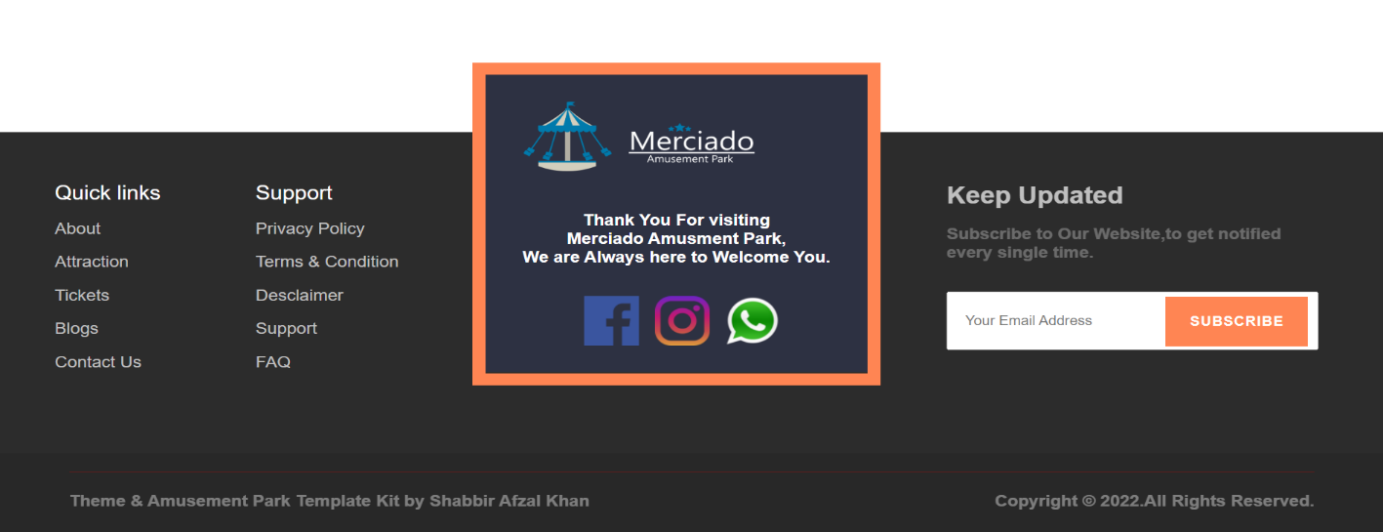**Footer:**

**1. Home Page:**

* 

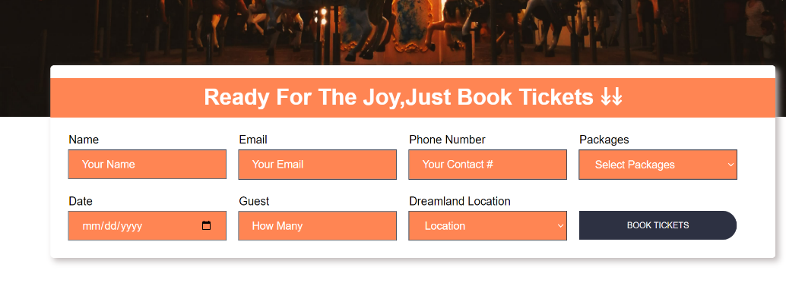



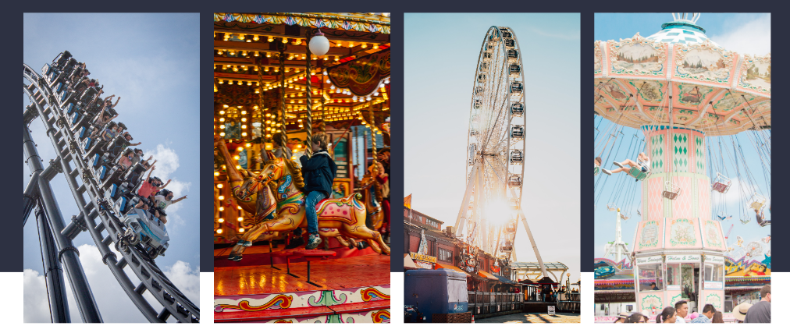

**2: About Us**

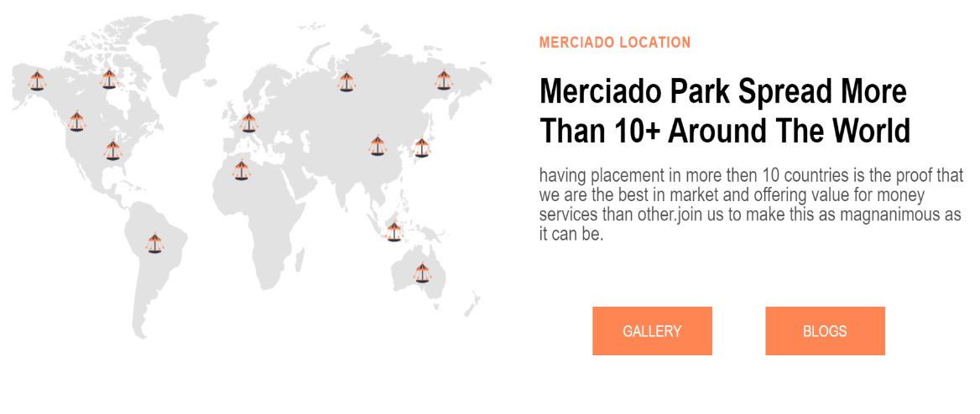





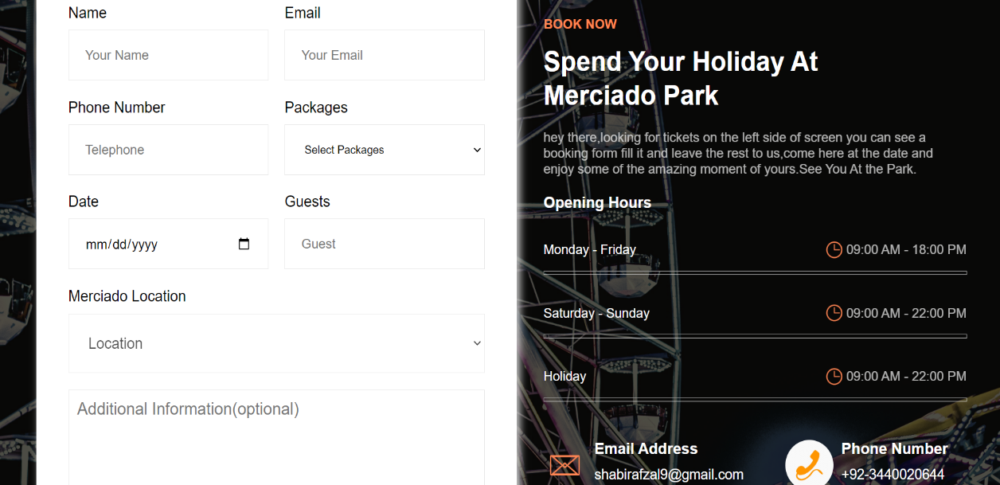**3:Tickets**

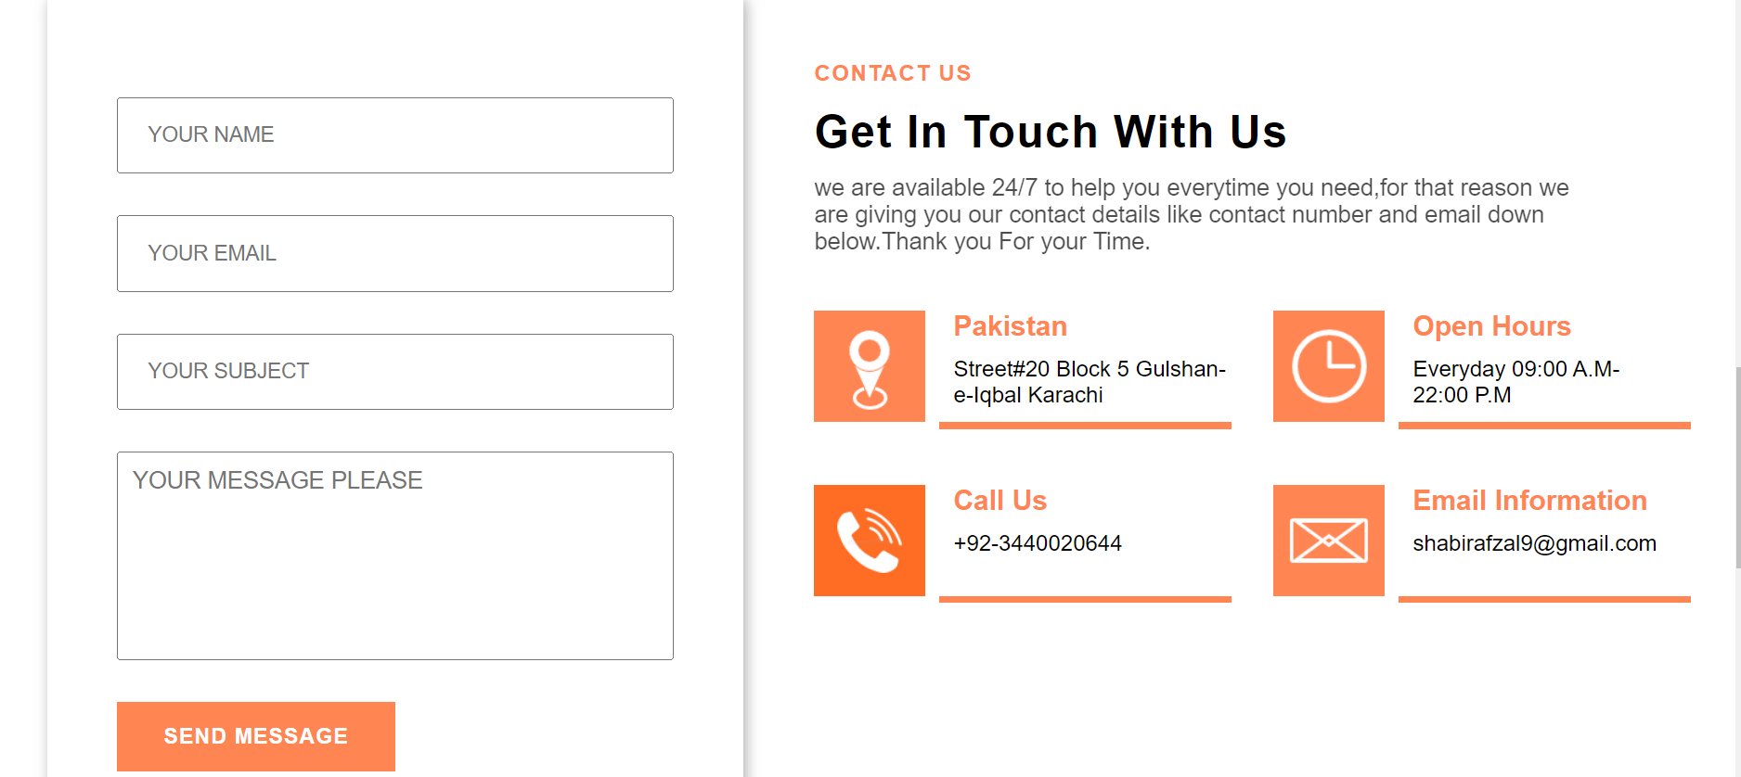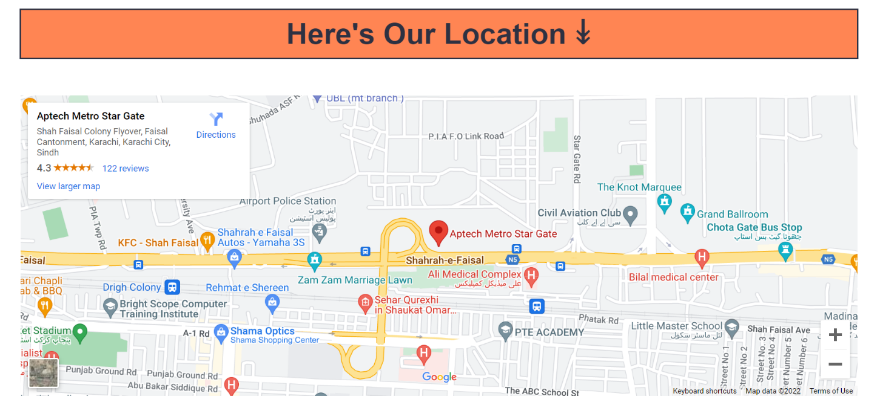**4: Contact Us**

Form Validation:

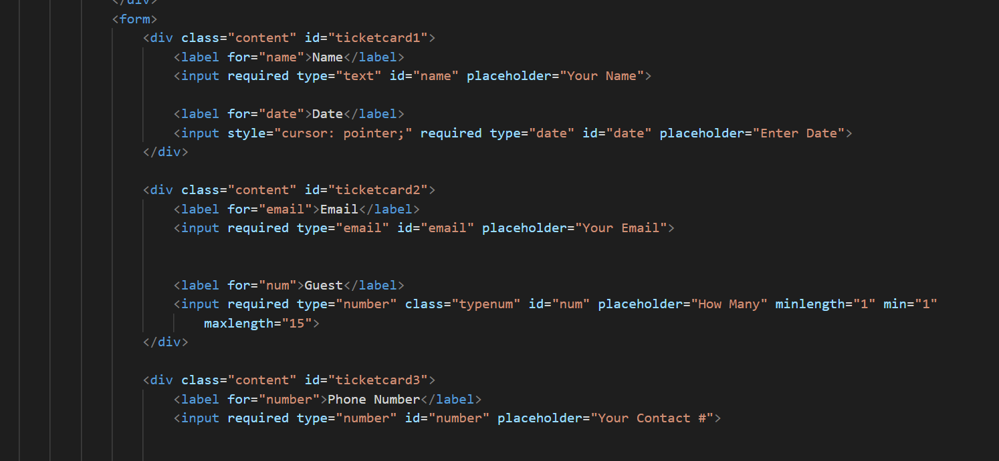

THANK YOU